A110-Eur-Crete-Mt. Ida-Minoan Kamares Ware-2100-1700 BCE

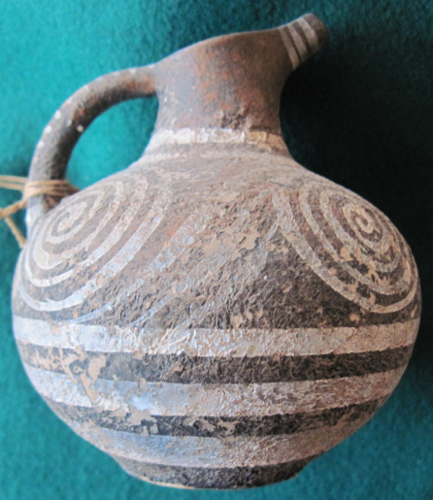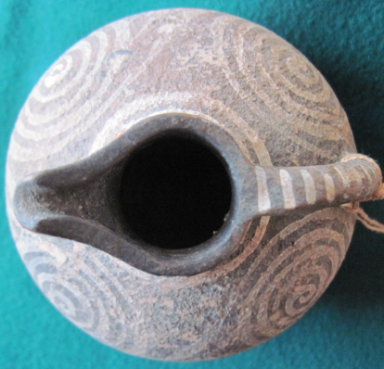 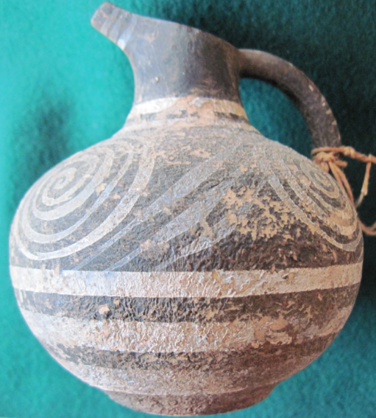

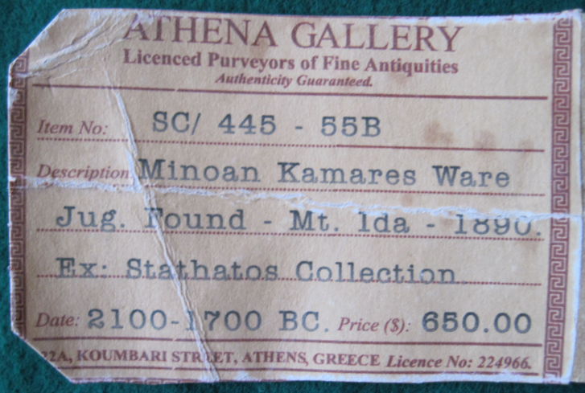

Figs. 1-4. Crete-Mt. Ida-Minoan Kamares Ware-2100-1700 BCE

**Case No.: 4**

**Accession Number: A110**

**Formal Label:** Crete-Mt. Ida-Minoan Kamares Ware-2100-1700 BCE

**Display Description:**

Wheel-made globular ceramic Kamares Ware with a strap handle. A brown slip is ornamented in an undulating white band below the rim enclosed within white lines above and below. This was discovered on the slopes of Mt. Ida, Crete, 1890, probably from the deep system of caves collectively called the Cave of Zeus where a large number of votive cult offerings have been found.

Kamares wares were produced from the Middle Minoan IA (ca. 2100 BCE) to the Late Minoan IA periods (ca. 1450, the end of the First Palace Period) when these wares decline in “vitality” of design (Dickinson 1994). Traditionally, Kamares wares have been interpreted as prestige artifacts. They are typically executed in white, red and blue on a black field in abstract floral motifs. This example is exemplary of the type of small, round spouted jars.

**LC Classification:**  [DF221.C8](http://cbbcat.net/search%7ES19?/cDF221.C8+A413+1973/cdf++221+c8+a413+1973/-3,-1,,E/browse)

**Date or Time Horizon:** Middle Minoan IA (ca. 2100 BCE)

**Geographical Area: Crete**

**Map:**

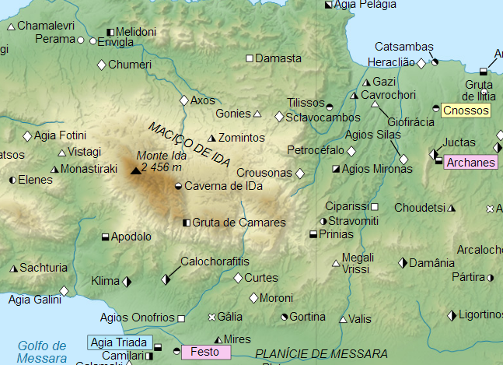

**Map of location of Mt Ida. From https://upload.wikimedia.org/wikipedia/commons/0/07/Crete_archaeological_sites-pt.svg**

**GPS Coordinates:** 35º13'35.08" N 24º46'14.59" E

**Cultural Affiliation:** Middle Minoan IA (ca. 2100 BCE)

**Geographical Area: Mt Ida, Crete**

**Medium:** ceramic

**Dimensions**: H 106.35 mm, 4.186 in  
**Weight:** 163 g, 5 5/8 oz

**Provenance: found on Mt. Ida 1890.**

**Condition:** original

**Discussion:**

In the Minoan period the Cave of Zeus was a place of worship, since it was believed to be the cave where the titan Rhea hid Zeus, to protect him from his father Cronus who intended to swallow him like others of his progeny.

**References:**

Alexiou, Stylianos. 1973. *Minoan civilization*. Translated from the Greek by Cressida Ridley.Heraclion: [Spyros Alexiou]

Dickinson, Oliver. 1994. *The Aegean Bronze Age*. Cambridge University Press.

Zinn, Evelyn Elizabeth. 1966. Kamares ware and its regional variations. Thesis (M.A. in History of Art)--University of California.